**HW_LAB_1_A:**

**Schematic Circuit of Simple Adder:**

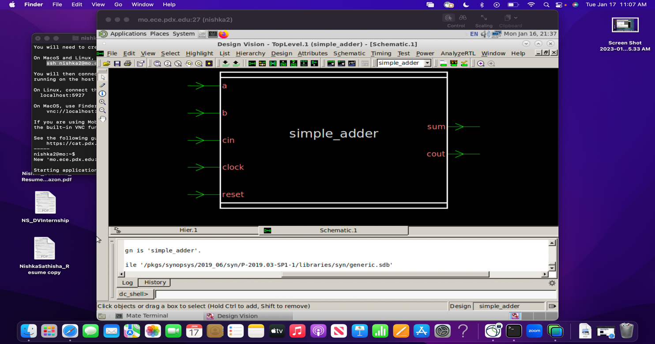

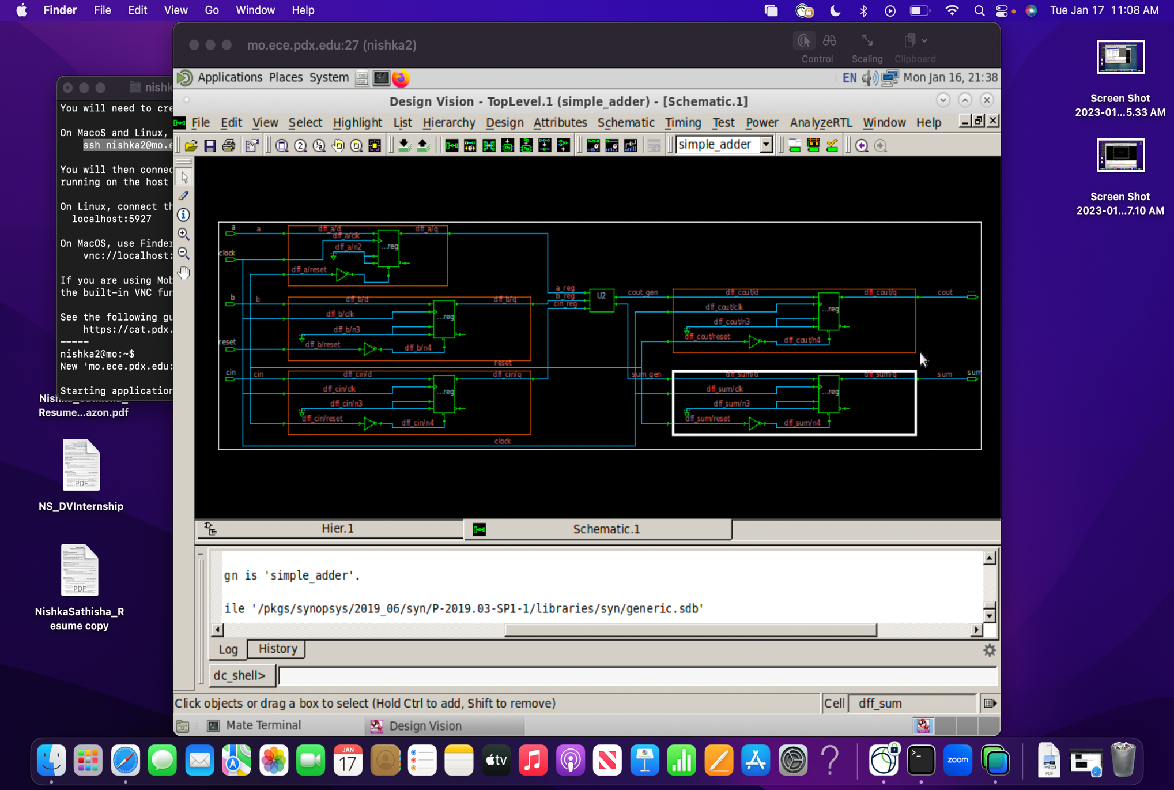

**Timing report:**

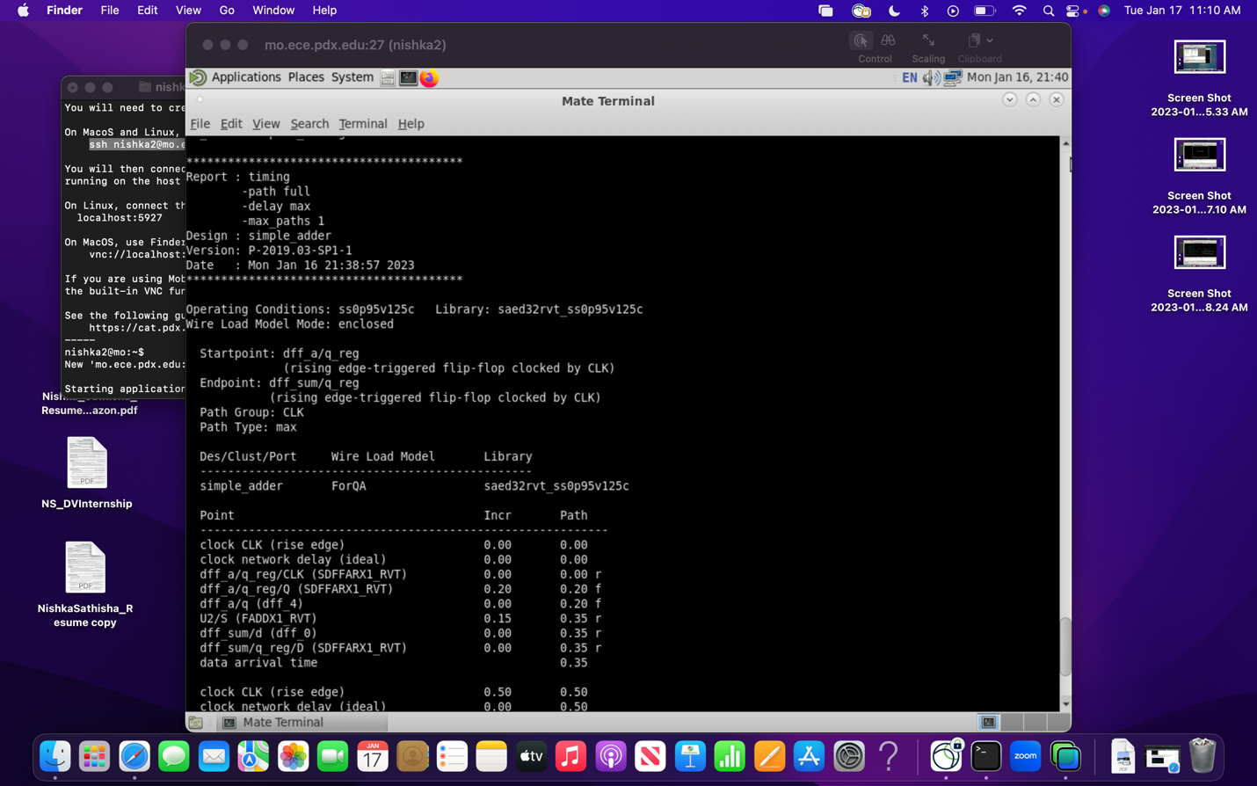

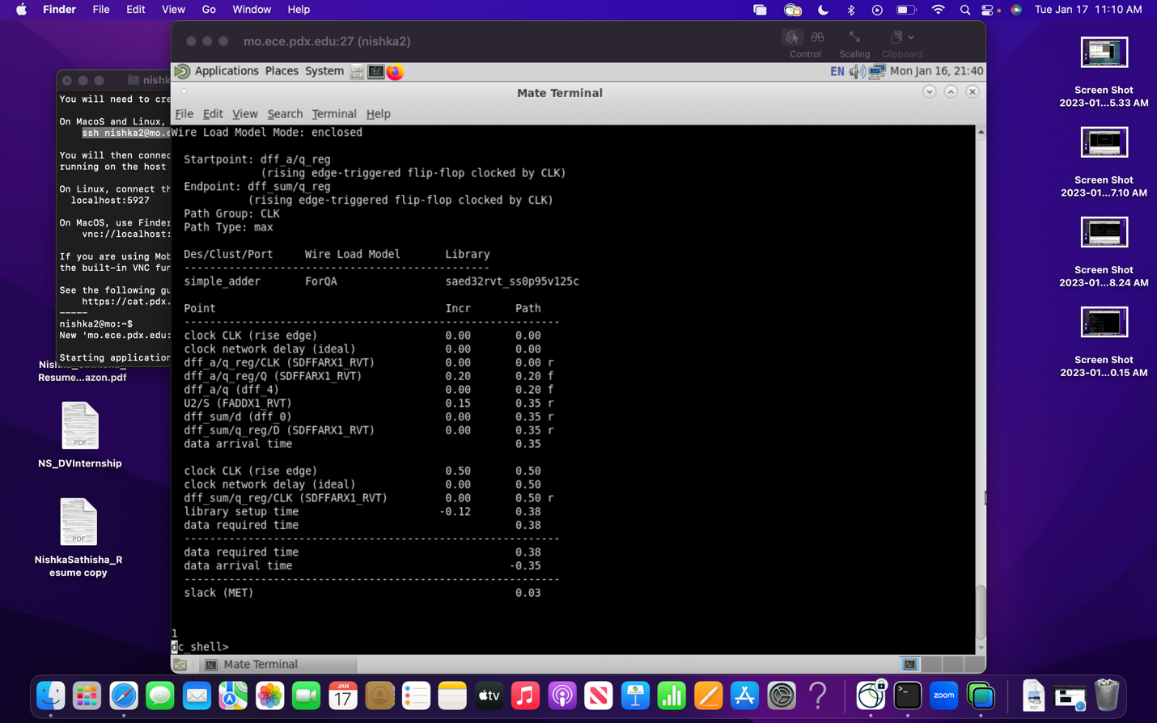

**HW_LAB_1_B:**

**Schematic circuit in Genus**

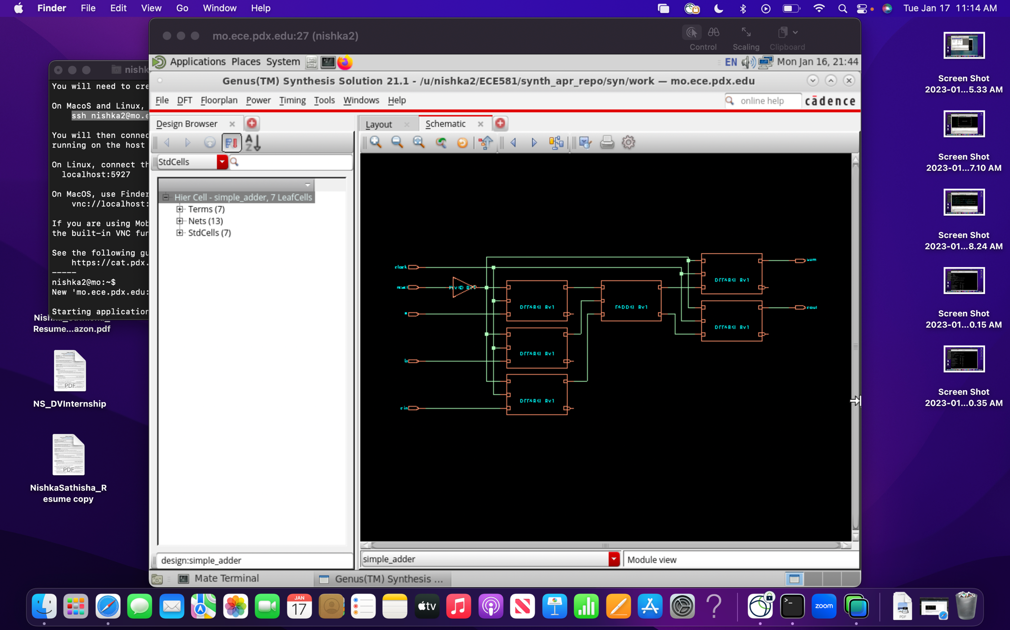

**Timing report in Genus:**

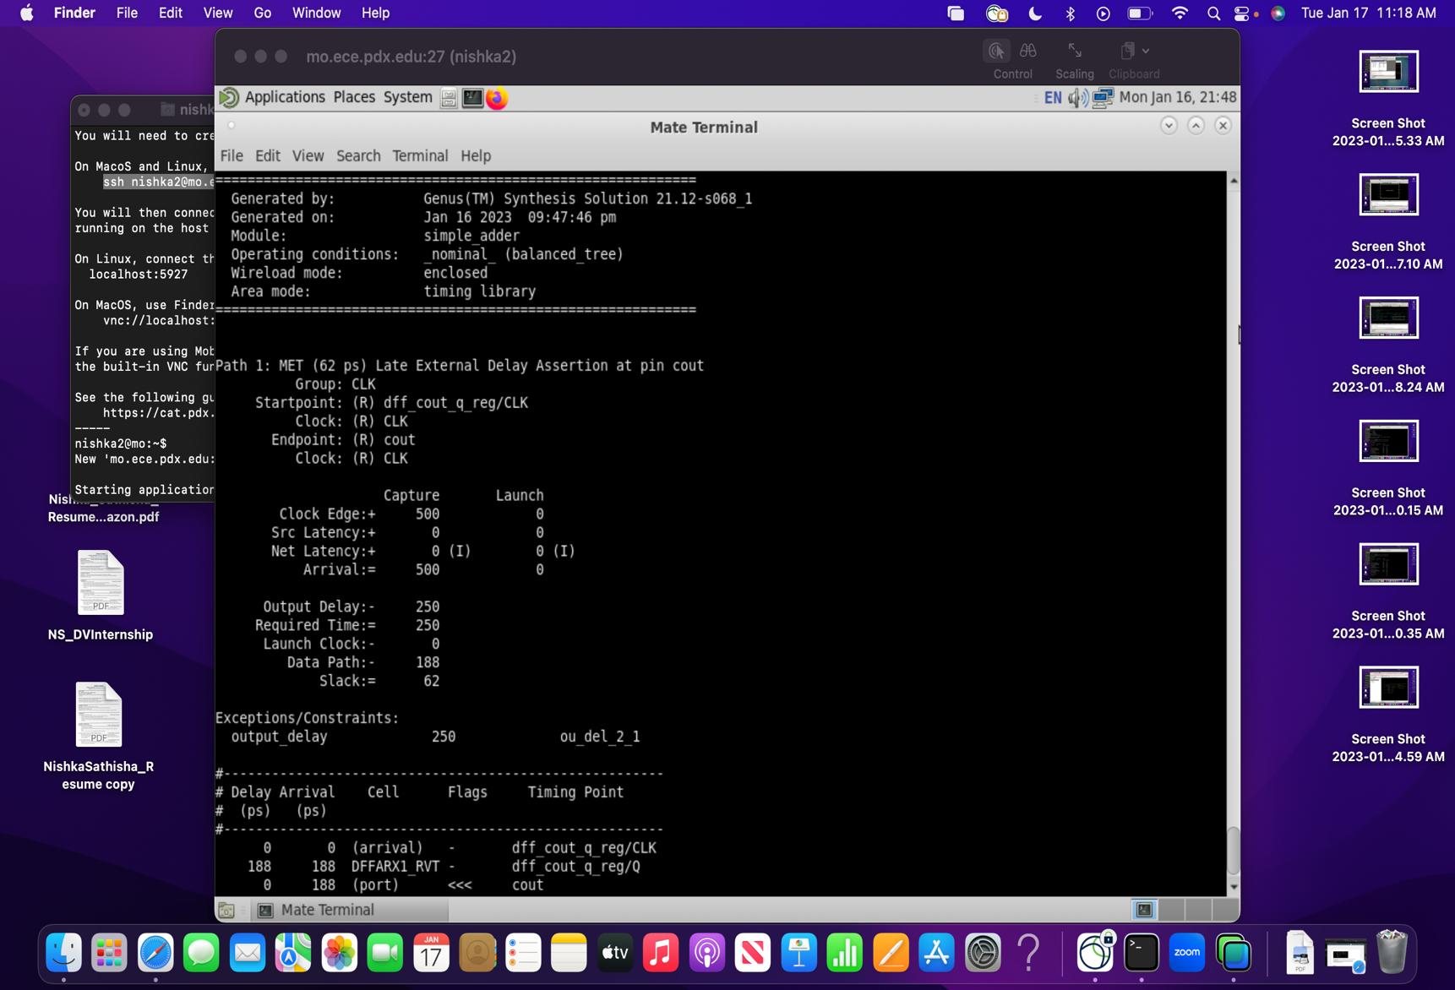

**Comparison Table:**

|  |  |  |
| --- | --- | --- |
| **CONSTRAINTS** | **DC** | **GENUS** |
| Cell count | 11 | 7 |
| Combinational cell count | 6 | 2 |
| Sequential cell count | 5 | 5 |
| Cell Area | 56.928257 | 41.680 |
| WNS | 0 | 0 |
| TNS | 0 | 0 |
| Violation Count | 0 | 0 |

**HW_LAB_1_C:**

**FE RTL WAVEFORM**

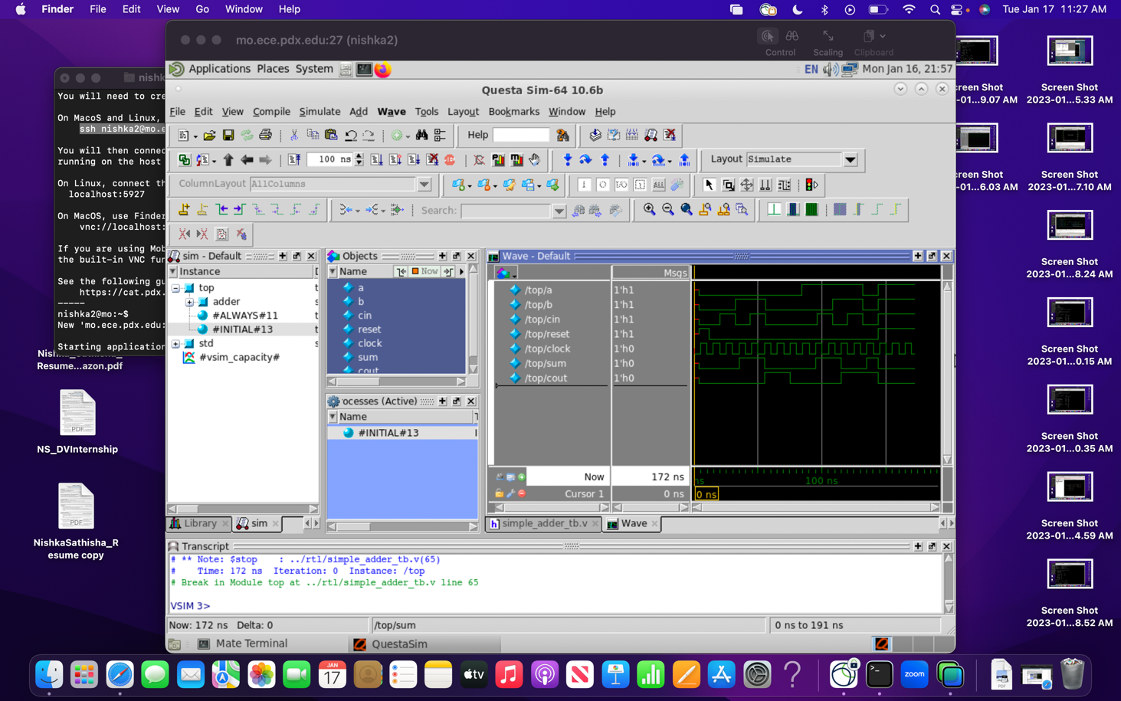

**ZOOMED VIEW:**

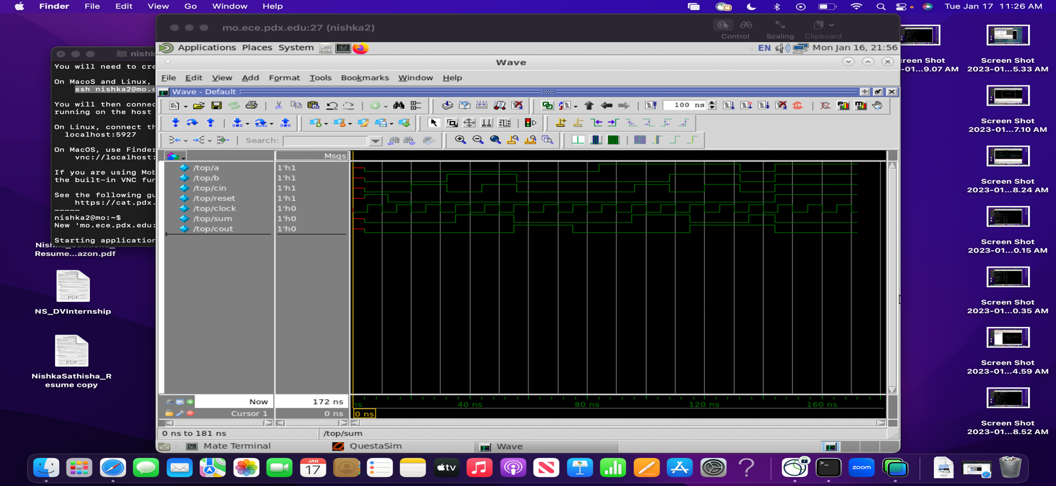

**BE Netlist Waveform**

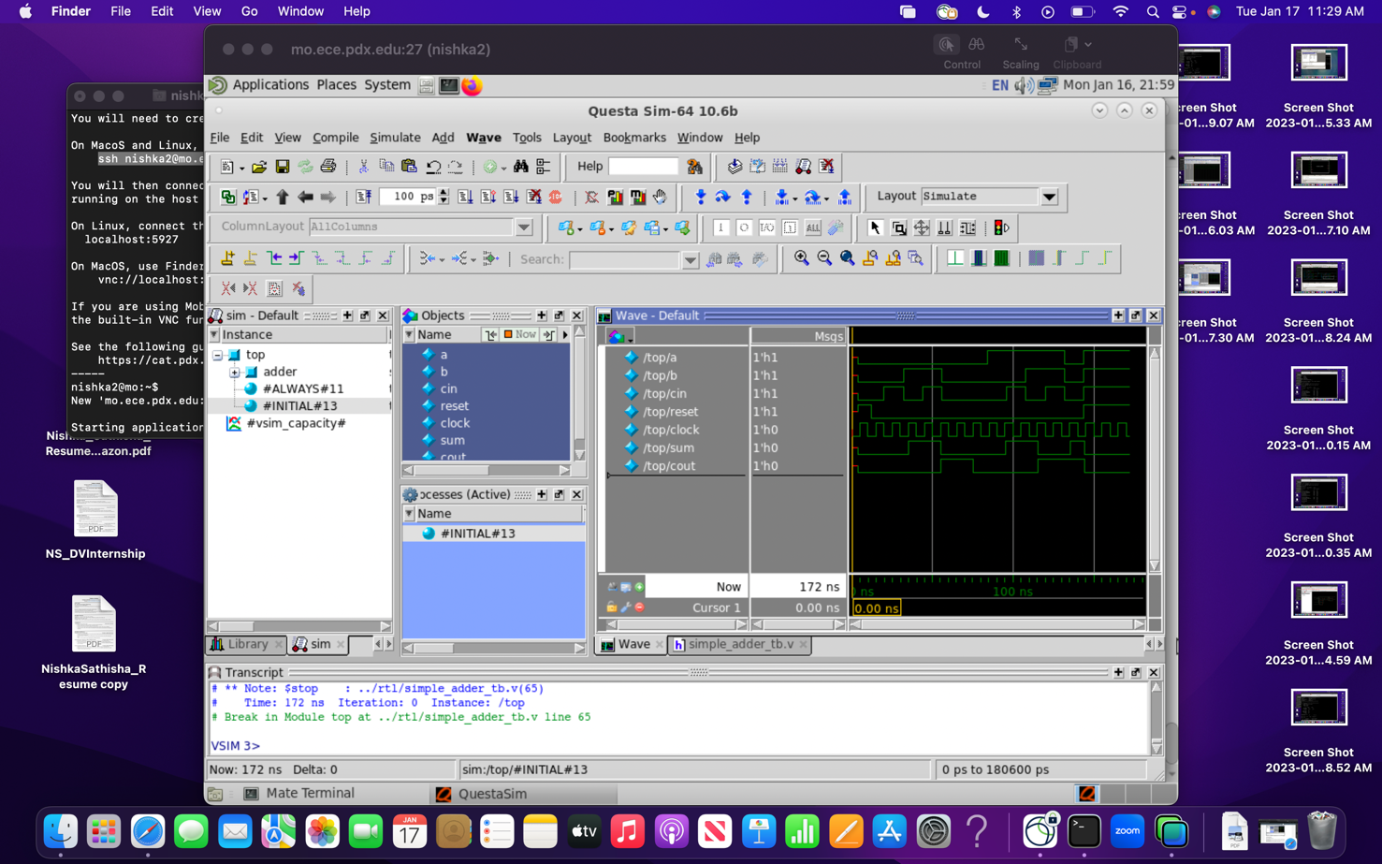

**Zoomed view**

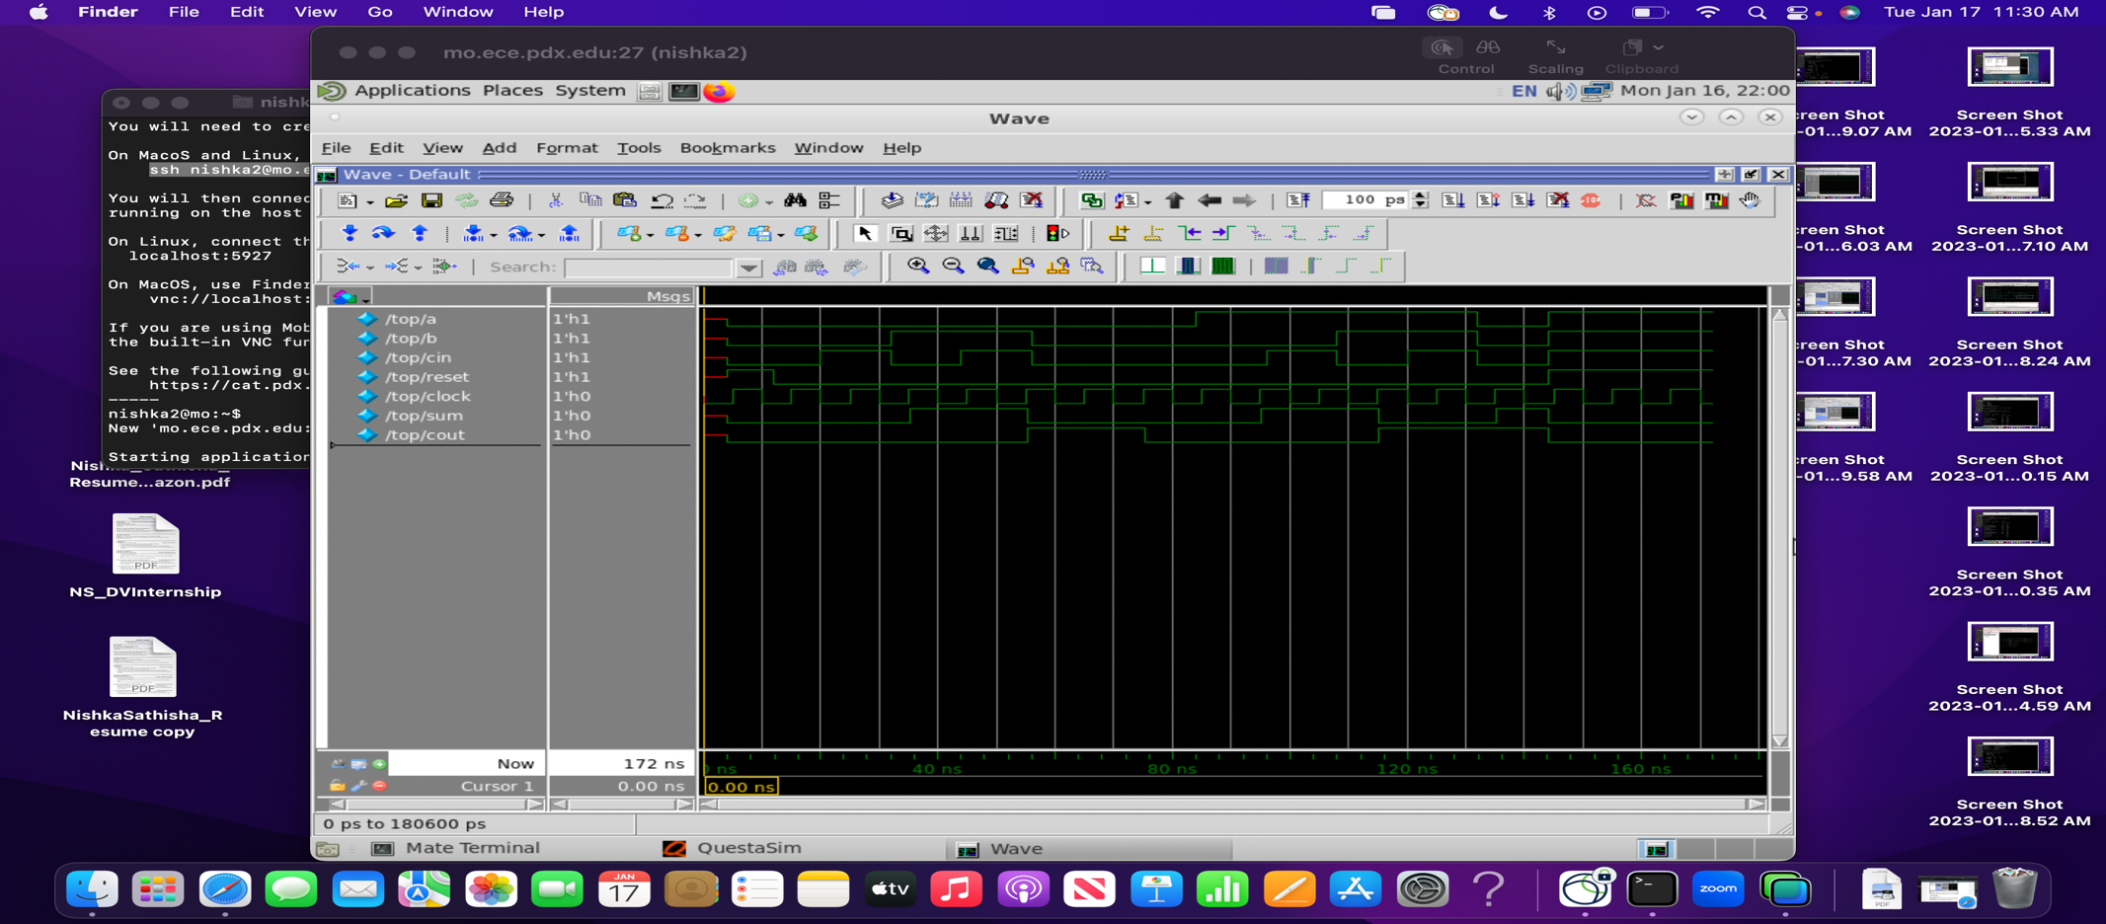

**Comparison statement FE RTL Netlist vs BE RTL Netlist**

The waveforms are same for both FE and BE and hence the RTL and generated netlist have similar functionality.

**Questa Commands:**

**vlib:** The vlib command creates a design library

**vmap**: The vmap command defines a design defines a mapping between a logical library name and a directory

**vlog**: The vlog compiler invokes the Verilog compiler and compiles all the Verilog files

**vsim**: The vsim command invokes the VHDL/Questa simulator

**HW_LAB_1_D:**

**LEC equivalency**

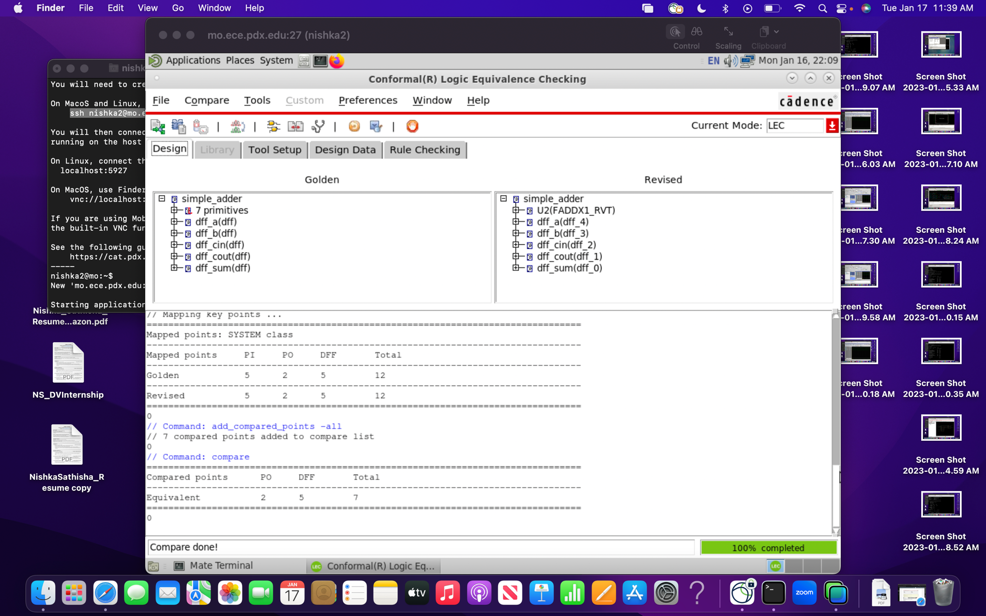

**LEC Command description:**

**Lec -tclmode:** Lec tool is invoked in tclmode

**Lec -dofile:** Lec tool is invoked and commands in dofile is executed

**read_design:** This reads the RTL or netlist, or the library files required for the lec run

**set_system_mode:** Used to switch system modes

**add_compared_points:** Used to specify which mapped points the conformal compares.

**Compare:** This compares the points added in the list and checks whether the key points are equivalent or not.

**HW_LAB_1_E:**

<https://github.com/nishkasathisha/Lab1>